**Ride sharing service**

**Task**: Implement a representation for taxi ride sharing service (e.g., DIDI, Uber, see Figure 1) concept using any microservices development framework, but we encourage implementing through Spring Boot or Swagger.

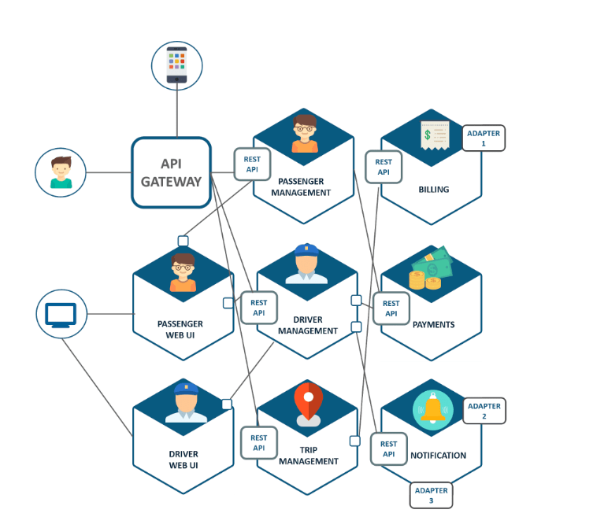

The following three microservices should be implemented.

1. Passenger management
2. Driver management
3. Billing

**Please note**

* Each microservice should contain at least 3 operations. For example, passenger management may have operations like 1) search ride, select type of ride, track ride location, and confirm the ride.
* Your implementation should contain the API gateway and REST APIs (RESTfull APIs) for communication
* Please try to solve these tasks in Java and make sure to include automatic tests for your implementation - for example, using a framework such as JUnit.